2/4/2019

Abbas Naqvi

177410

Digital Image Processing

Lab 2

# Task # 1

Code:

import PIL

from PIL import Image

im = Image.open("lab1.jpg")

print (im.format , im.size , im.mode)

im.show()

**Screenshots**

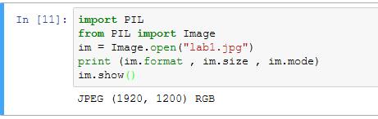

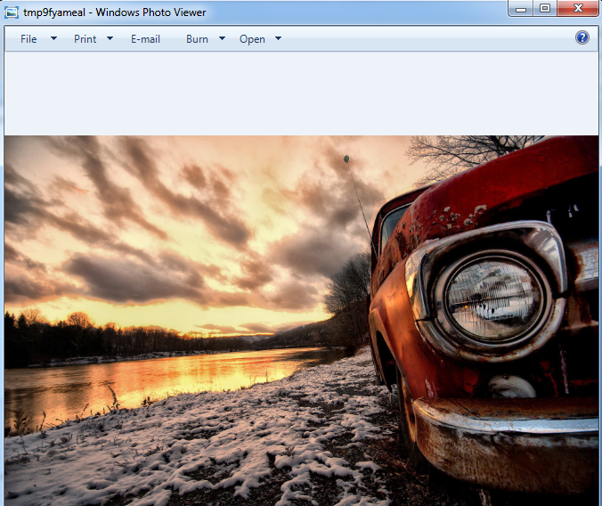

Code:

import os, sys

import PIL

from PIL import Image

images = ["lab1.jpg" , "lab1b.png"]

for infile in images:

f,e = infile.split(".")

outfile = f + ".jpg"

if infile != outfile:

try:

Image.open(infile).save(outfile)

except IOError:

print ("cannot convert", infile)

**Screenshots**

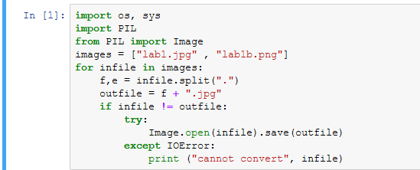

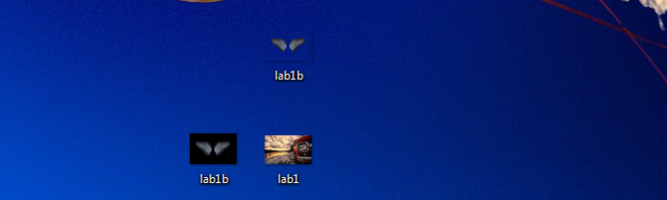

# Task # 3

Code **A**:

import os, sys

import PIL

from PIL import Image

im = Image.open("lab1.jpg")

greyScaleImage = im.convert('L')

greyScaleImage.save("greyscale.jpg")

greyScaleImage.show()

**Screenshots**

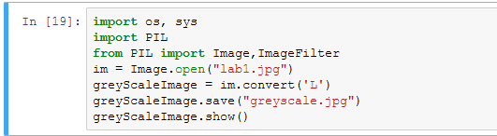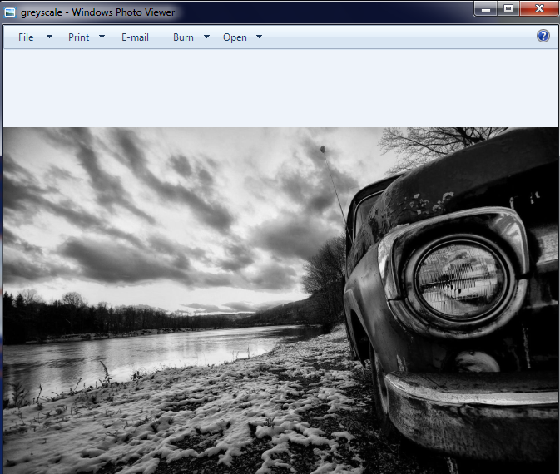

Code **B**:

import os, sys

import PIL

from PIL import Image,ImageFilter

im = Image.open("lab3b.jpg")

smoothImage = im.filter(ImageFilter.SMOOTH)

smoothImage.save("smoothImage.jpg")

smoothImage.show()

**Screenshots**

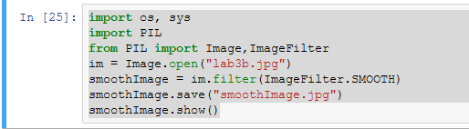

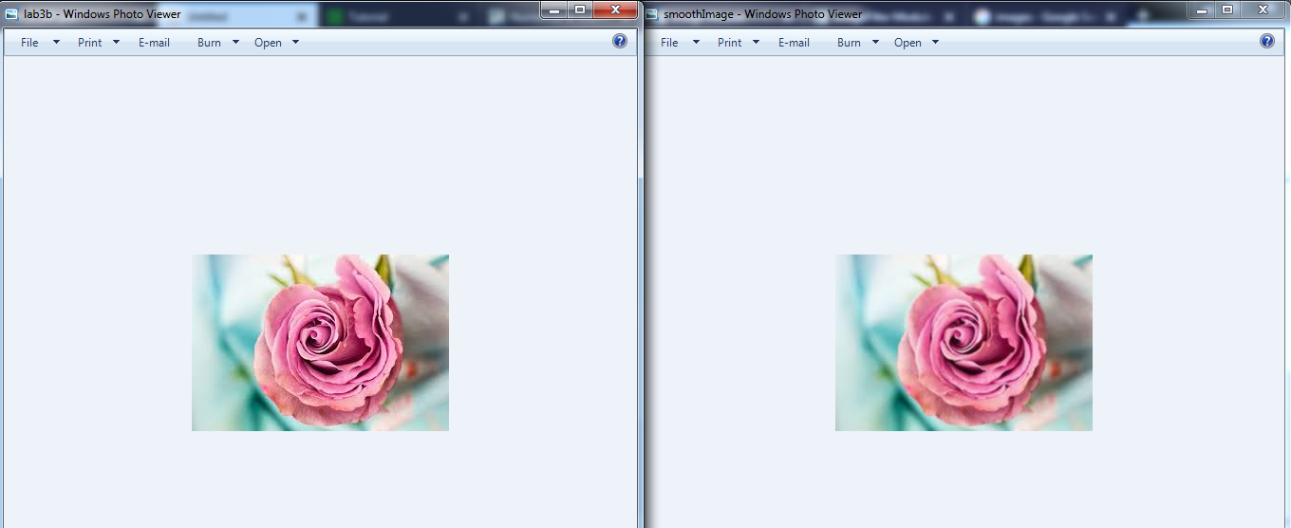

Code **C**:

import os, sys

import PIL

from PIL import Image,ImageFilter

im = Image.open("lab3b.jpg")

sharpenImage = im.filter(ImageFilter.SHARPEN)

sharpenImage.save("sharpenImage.jpg")

sharpenImage.show()

**Screenshots**

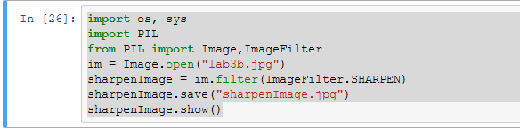

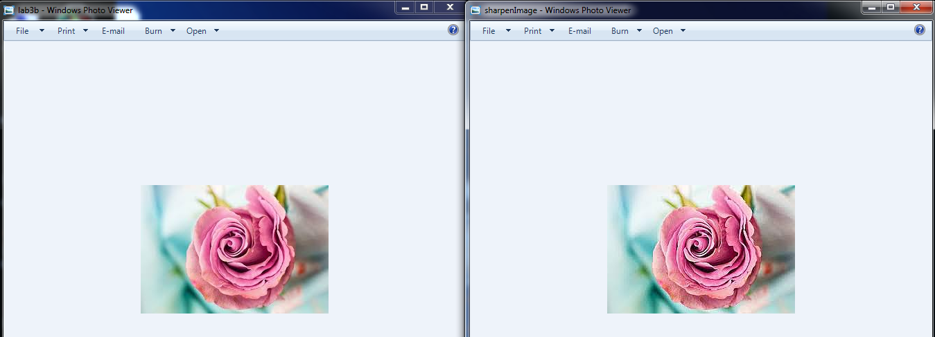

Code **D**:

import PIL

from PIL import Image

import numpy as np

im = Image.open("lab3b.jpg")

pixel = np.array(im)

Red = pixel[:,:,0]

Green = pixel[:,:,1]

Blue = pixel[:,:,2]

y =(Red * 0.2126 + Green * 0.7152 + Blue * 0.0722)

greyscale = Image.fromarray(y)

greyscale.show()

**Screenshots**

